Chapter 2, Problem 41.

If R_{eq} = 50 Ω in the circuit in Fig. 2.105, find R.
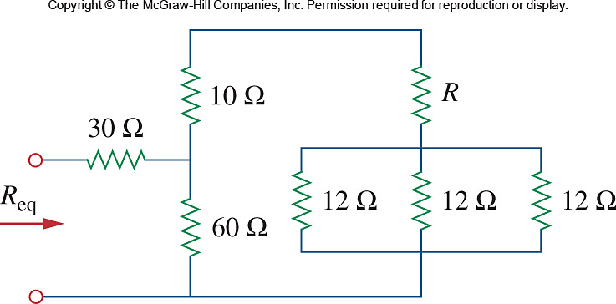

Figure 2.105
For Prob. 2.41.

